Cayuse Human Ethics New Submission Walkthrough

- Log in to Cayuse (appstate.app.cayuse.com)
- From the Home Screen, Click on “Products” and select “Human Ethics”
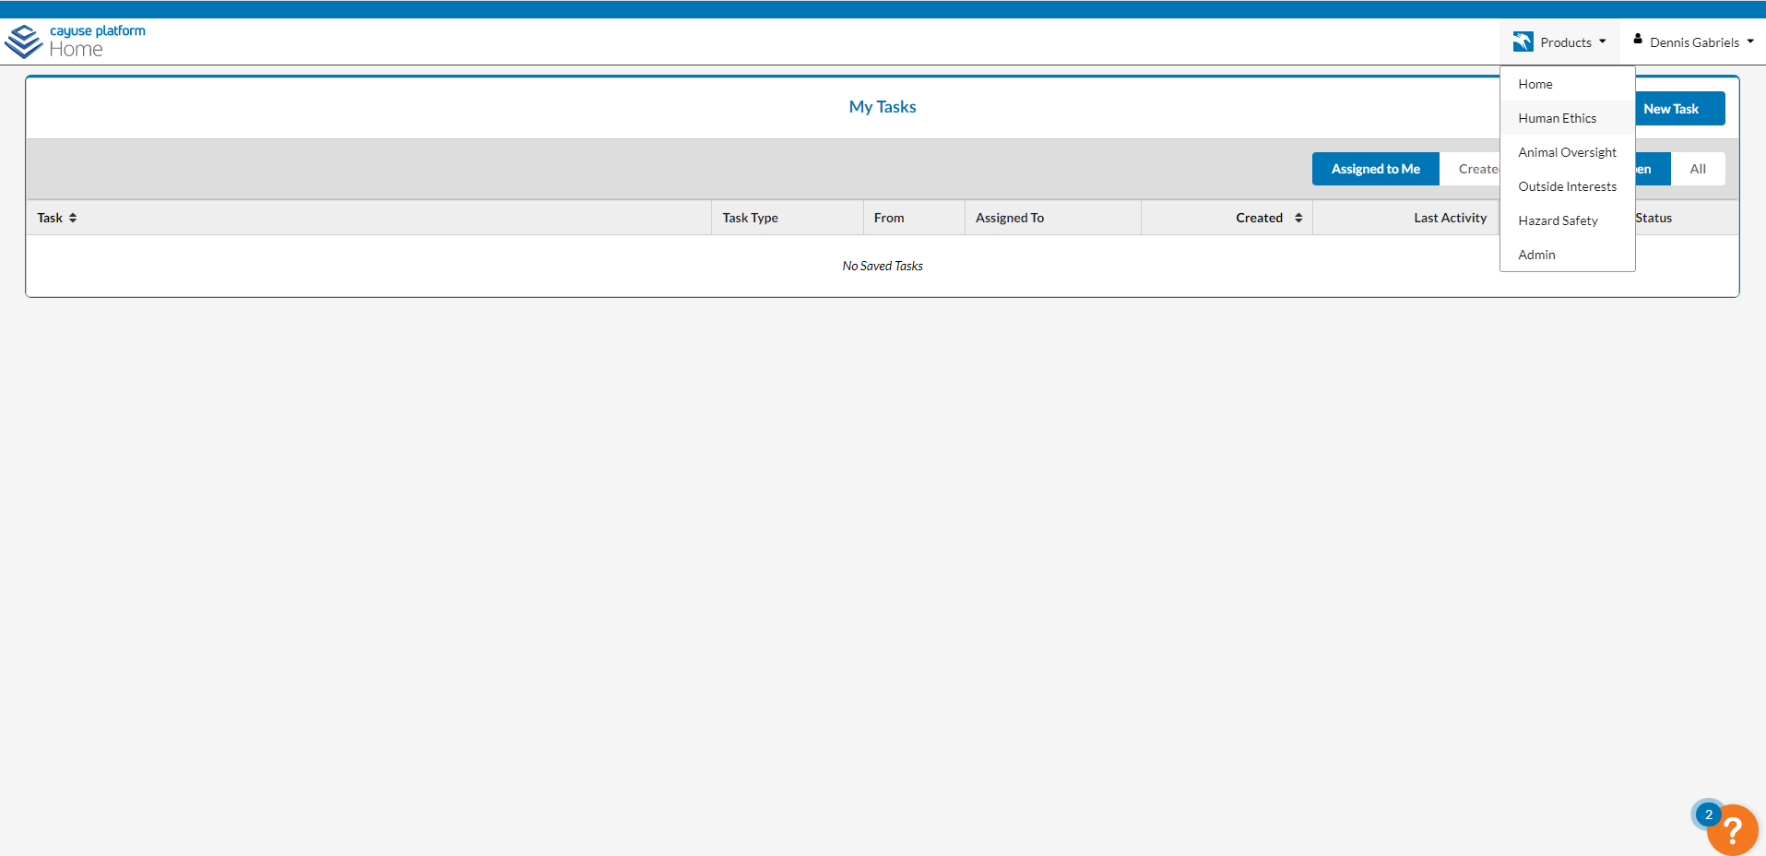

- Creating a new submission
  - Click on the “+ New Study” button
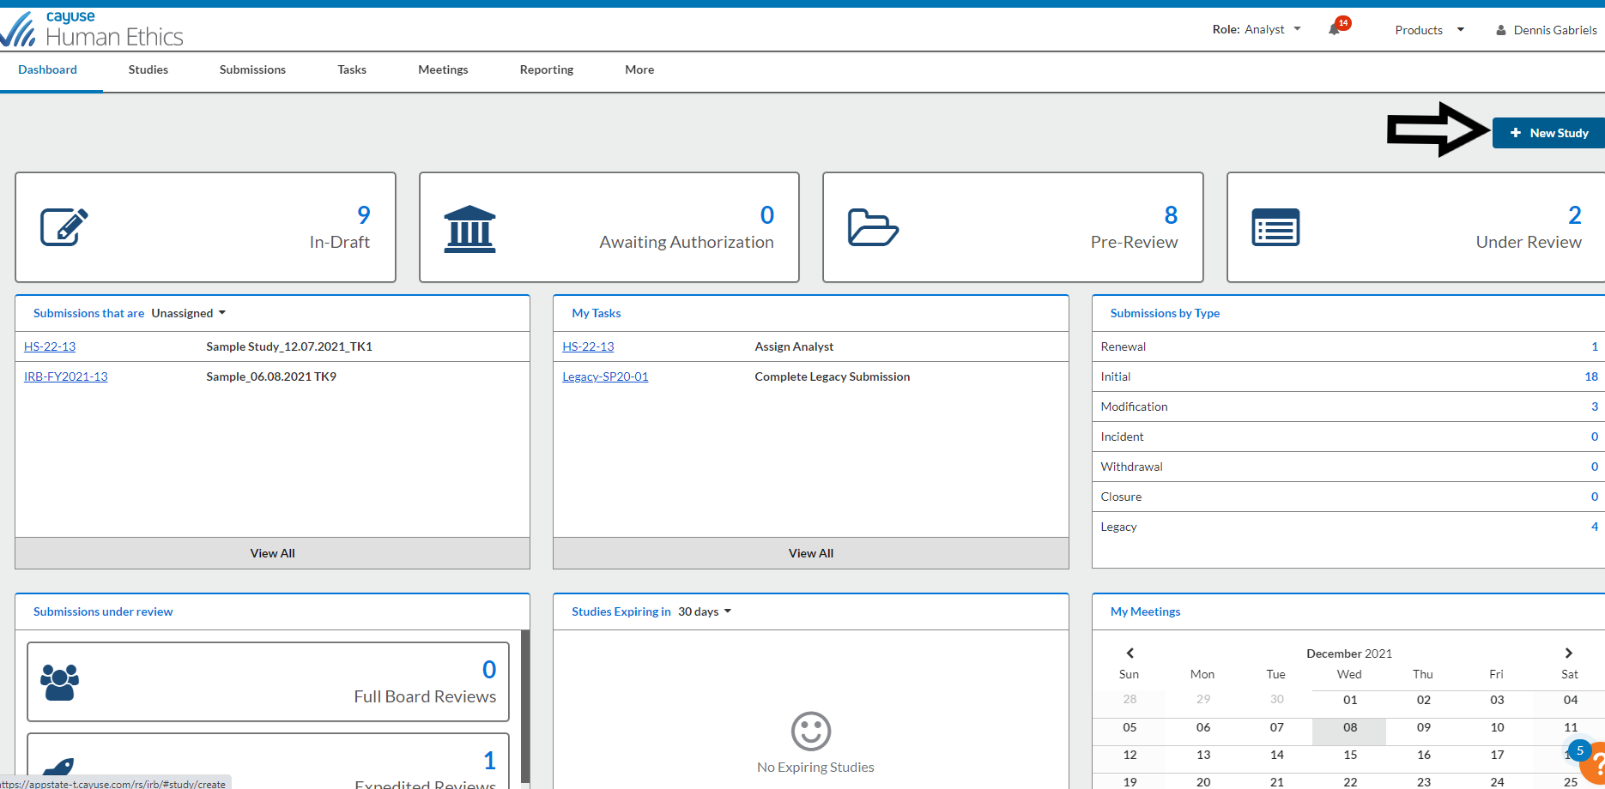

  - Under study Details, fill in the Study Title and click on the Blue checkmark to confirm.
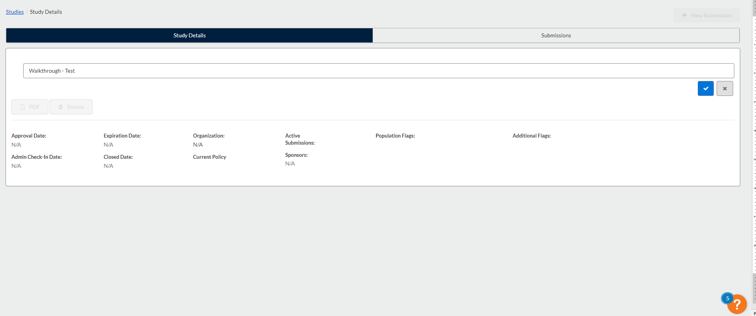

  - Click on the “+New Submission” button and select “Initial”
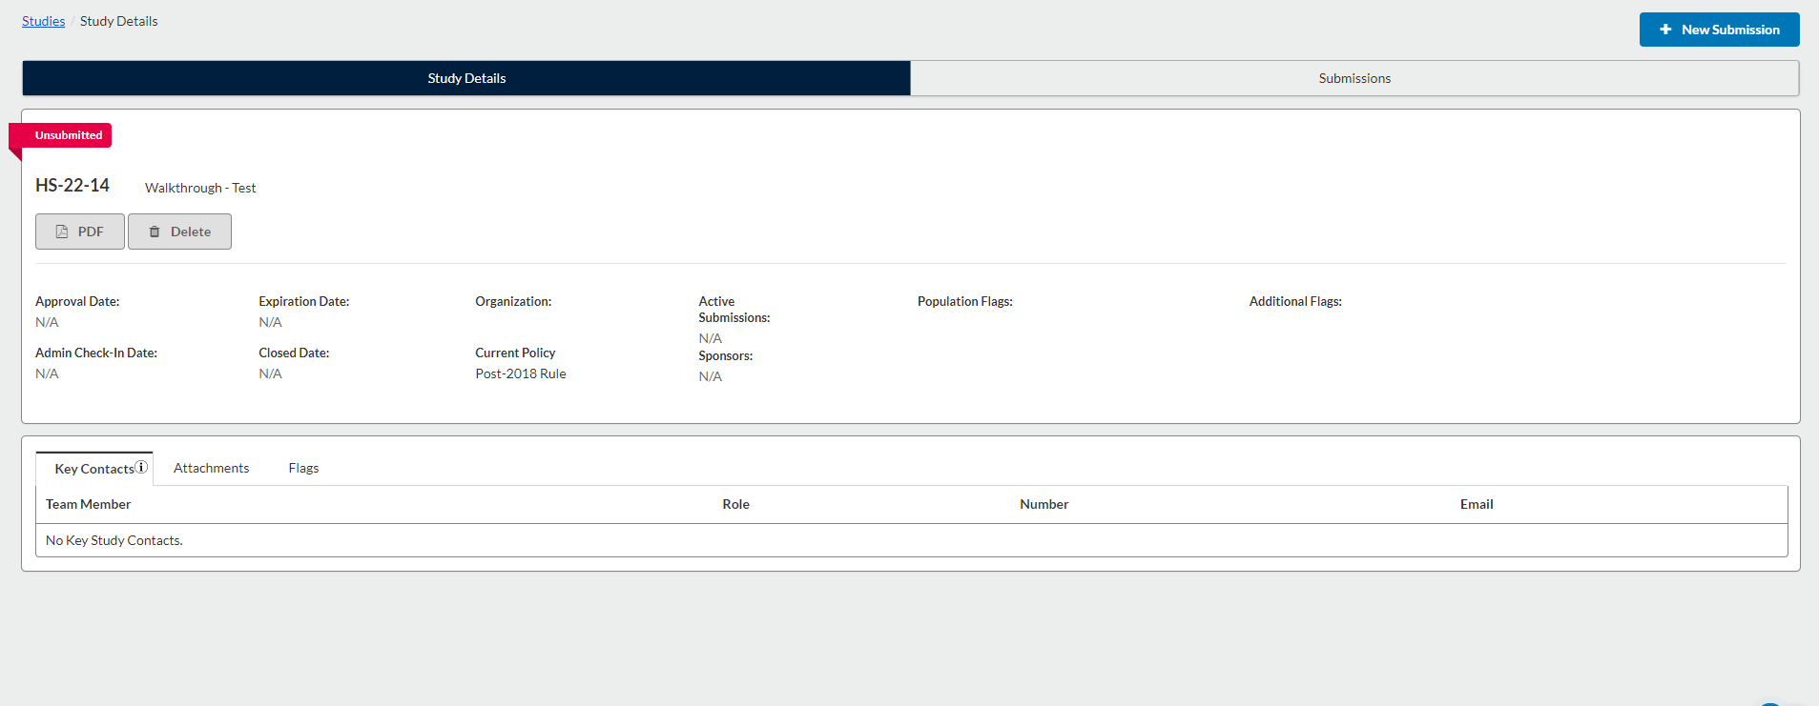

  - On the next screen. Click on “Edit”
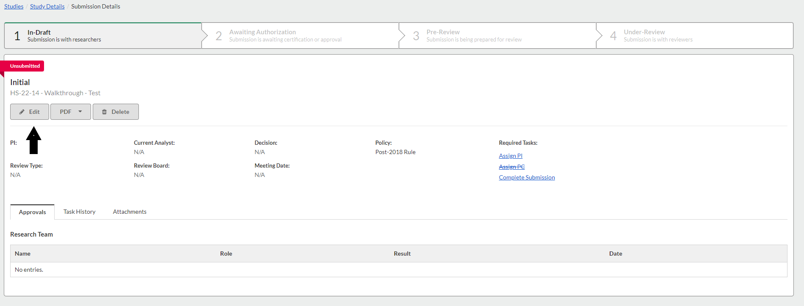

- Getting Started

  - Review the information and check the checkbox at the bottom of the screen.
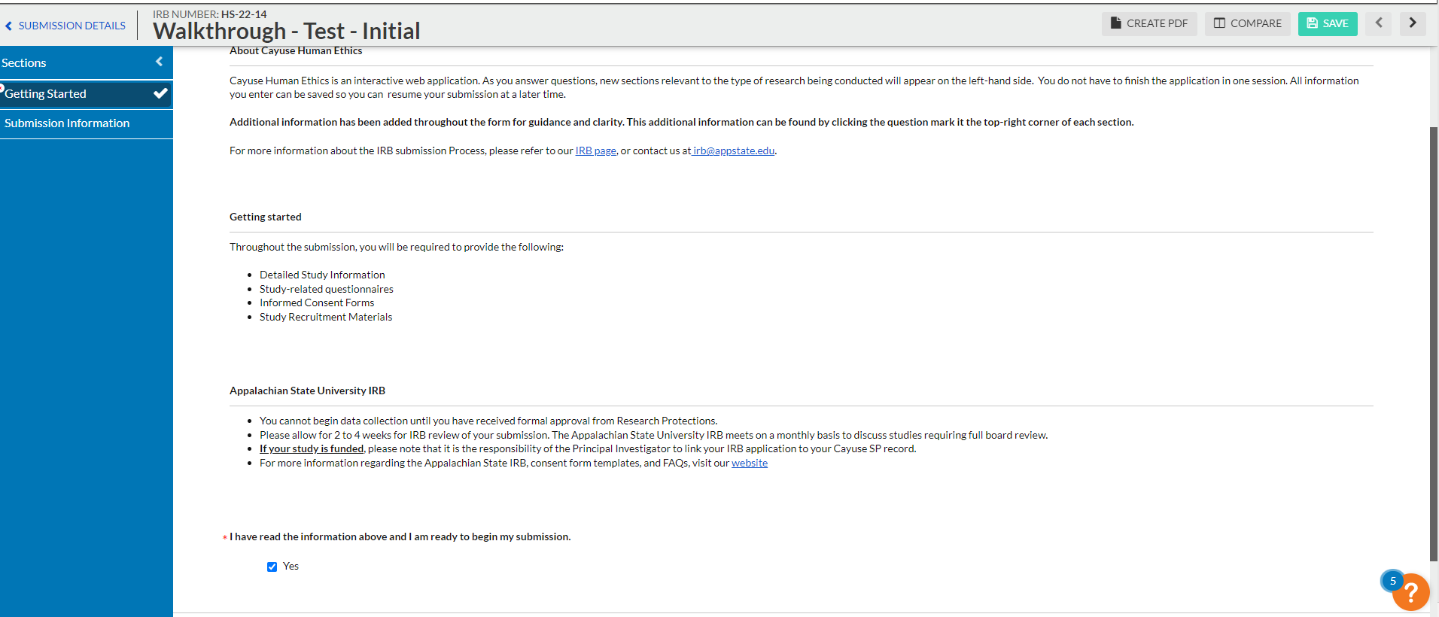
- Submission Information
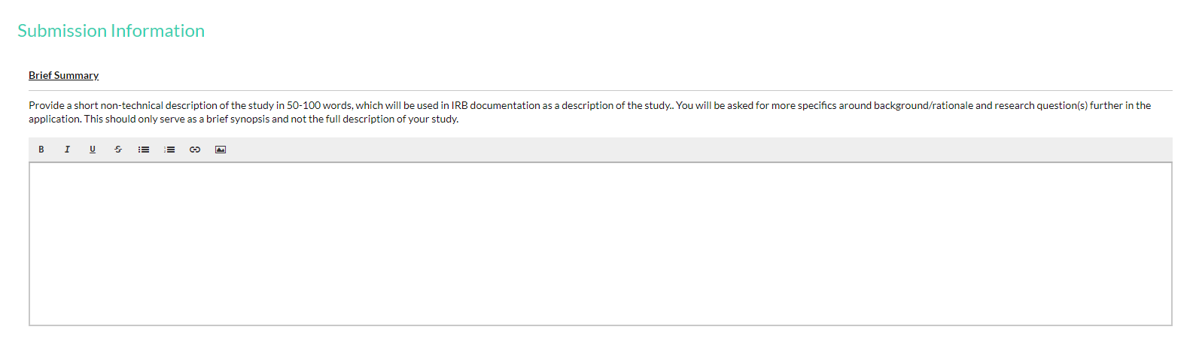

  - Complete the “Personnel” section
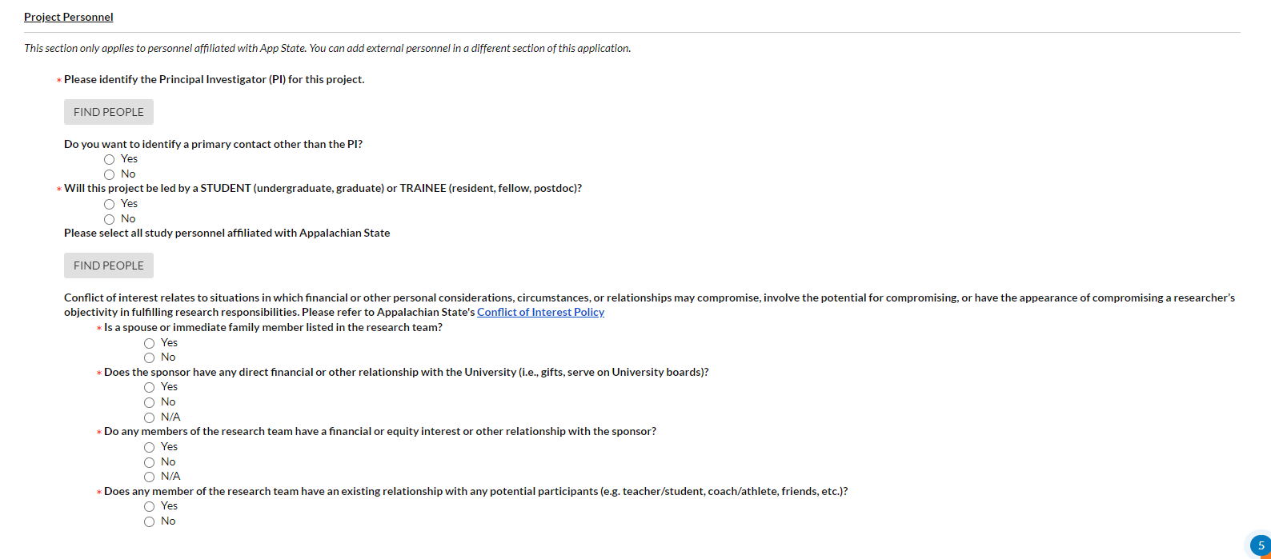

    - Click on the “Find People” button to pull up the pop-up screen below.
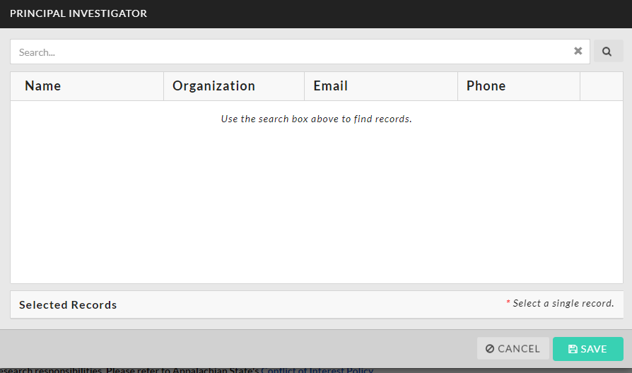

In the search field, enter your name and hit “Enter”. This will pull up a list of people that share that name. Select your information by click on the “+” button after your name.
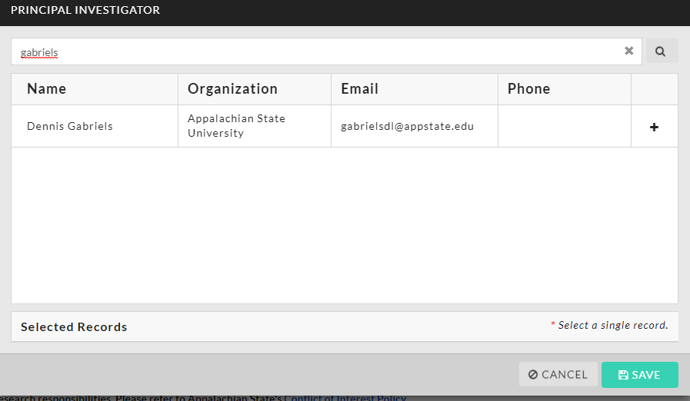

This will Select your record and a checkmark will appear. Click Save.
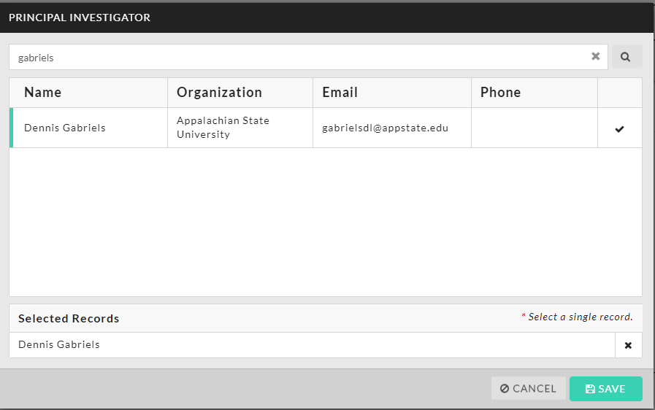

    - If you would like to identify a primary contact other than the PI, click “Yes” and repeat the steps as outlined above to add an additional contact
    - If the PI is a student or trainee, select the Faculty Advisor following the same steps.
    - Add all Appalachian State affiliated research personnel by using the “Find People” function
    - Complete the Conflict of Interest questions. Additional information will be requested if a conflict is identified.
  - Answer the “Funding Sources” questions as appropriate.
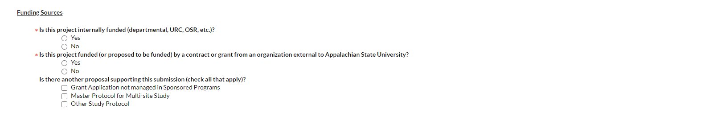

  - Answer the questions for the “Is this research?” section. The answers in this section will help drive the form to ask further appropriate questions.
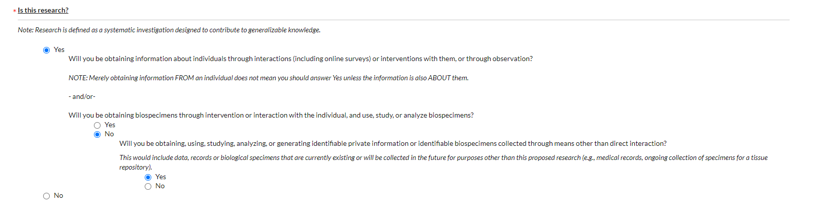

  - Answer the question(s) related to ARHS.
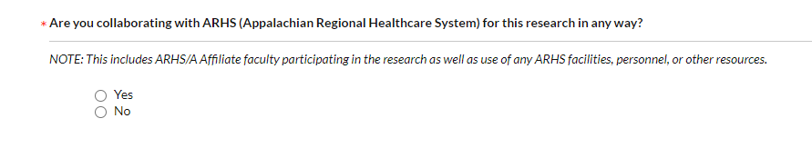
  - Complete the “Is this is a multi-institutional study?” section
If yes, complete the questions as follows:

    - Appalachian State will be the IRB of record
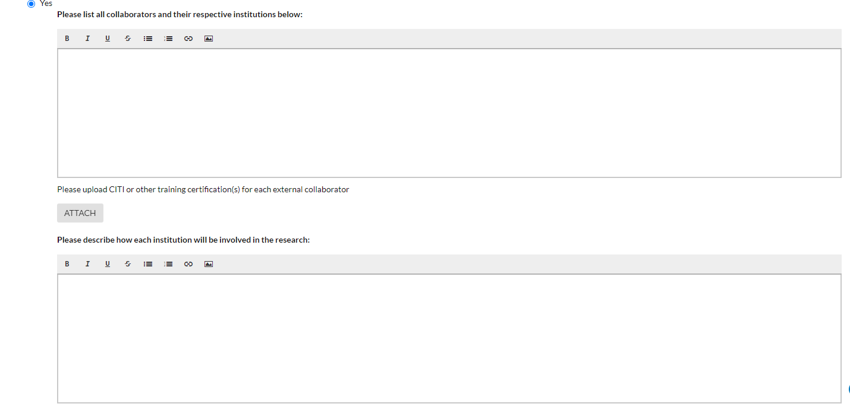

    - If another institution is the IRB of record.
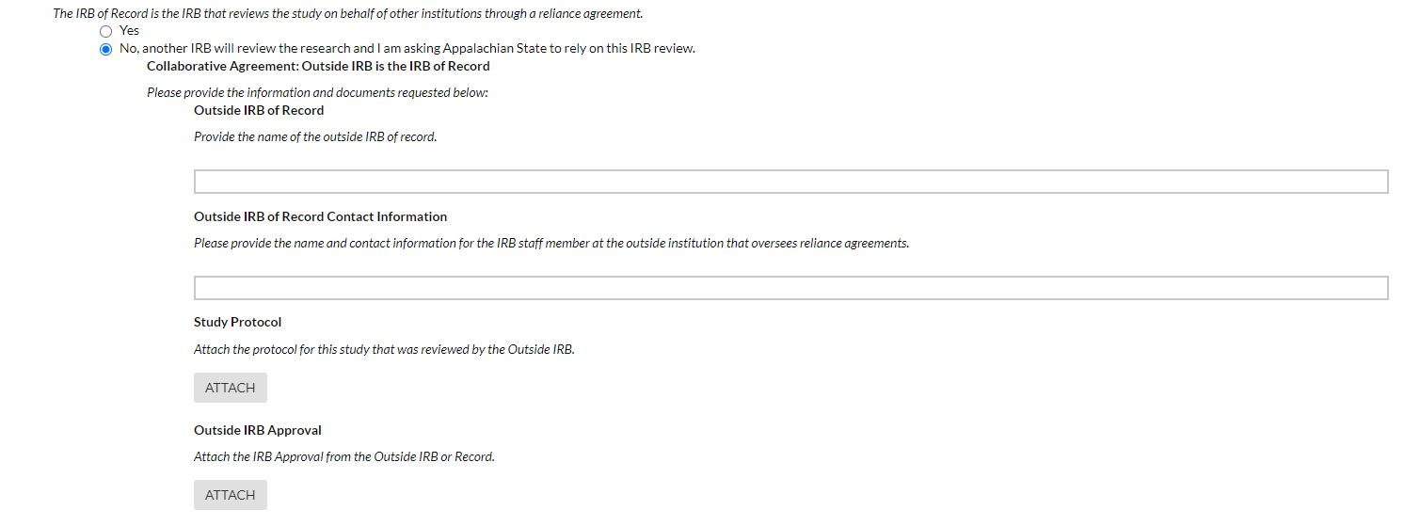
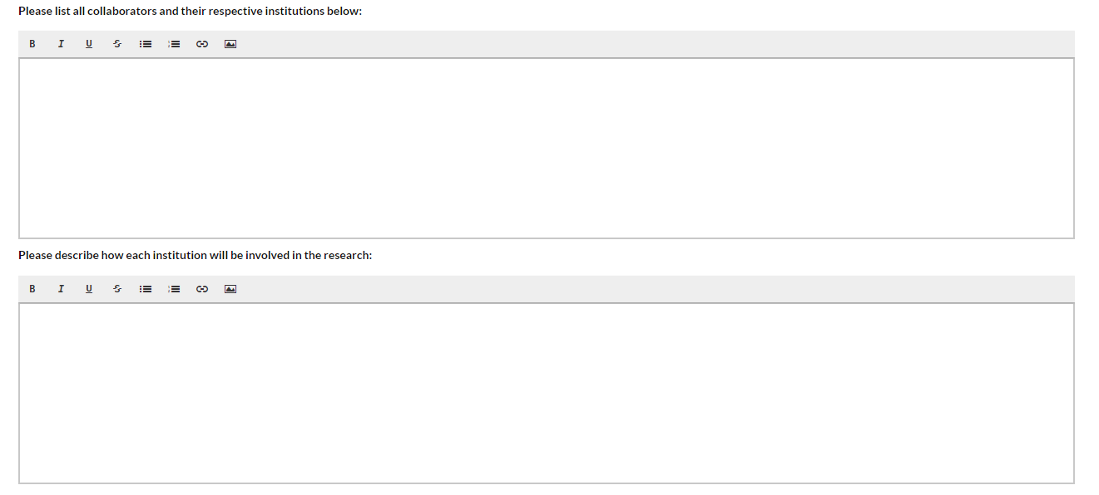

After completing the Submission Information, one of 2 sections will appear:
- NHSR – Click on the NHSR section on the left side of your screen
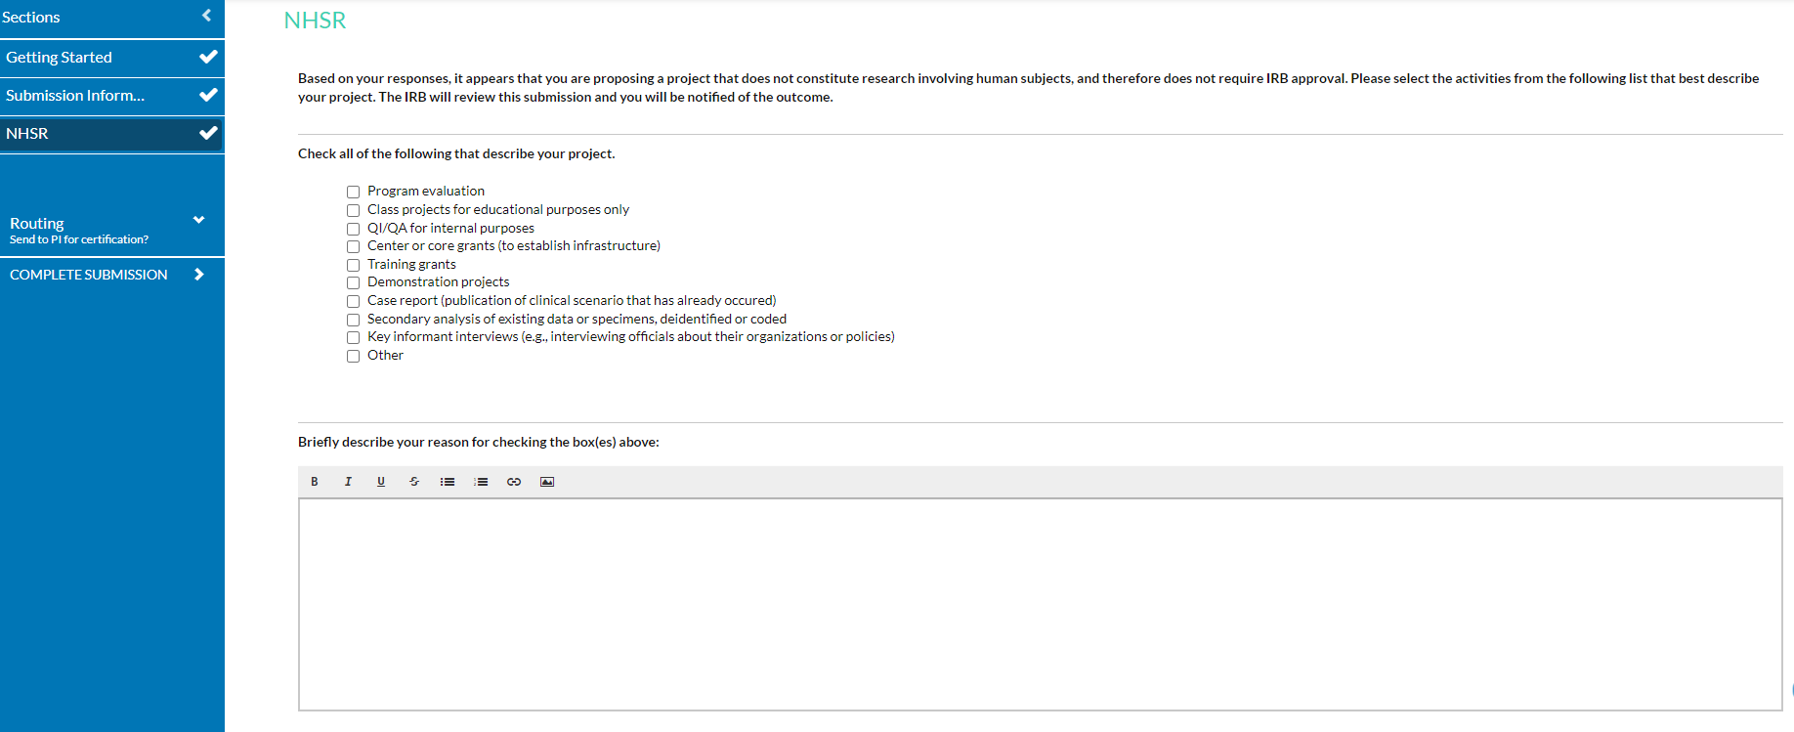
Indicate any descriptions that apply to your project and provide a brief explanation. If your study is considered Not Humans Subject Research, please skip to section -insert-

- Exemptions – Click on the Exemptions section on the left side of the screen
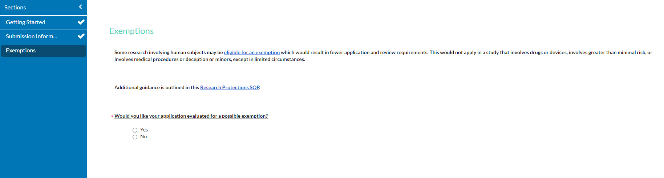
Indicate whether you want to evaluate your study for a possible exemption (please refer to our exemption guidance)
If Yes, go to section 8. If No, please skip to section 9.
NOTE: If you study involves prisoners as participants, or if it is FDA-regulated, you will not be able to apply for an exemption

- Exemptions
  - If your study qualifies for an exemption, please indicate this by selecting the appropriate exemption category (or categories).
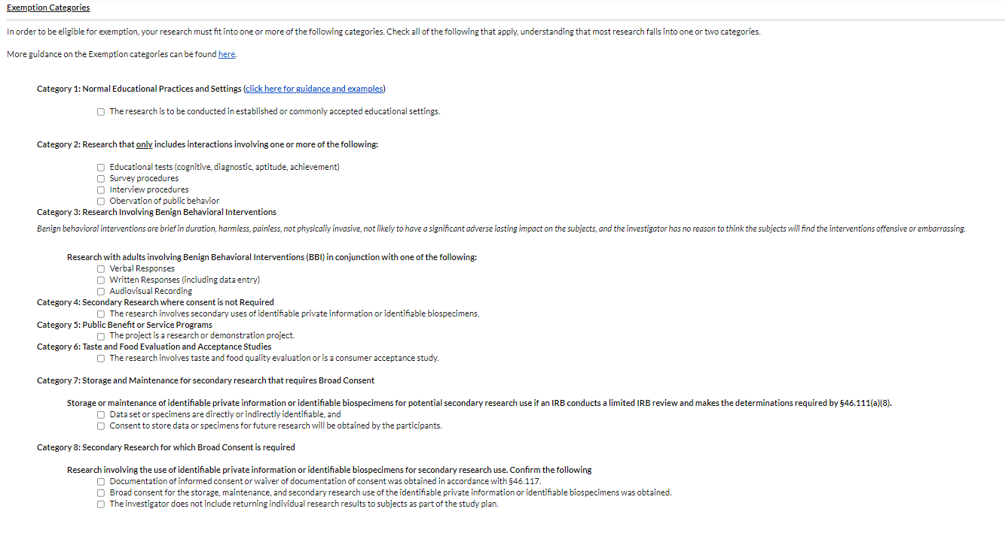
Categories 1-6 require additional conditions to be met when applying for an exemption in those categories. Please see the example below:
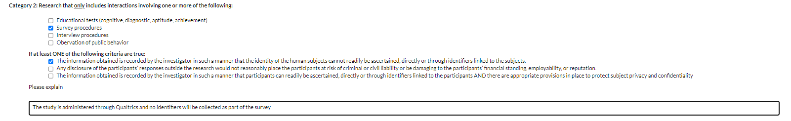
Additional section will be displayed on the left side of your screen. Please skip ahead to section 17.
  - If your study does not qualify for an exemption, select “No”. This will display additional sections, which will be described below:
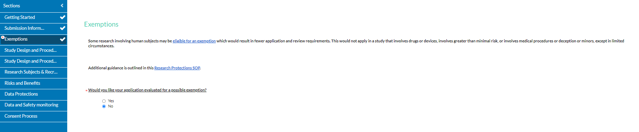

- Study Design and Procedures (All)
This section will display for all studies. Please complete the section as follows:
  - Background and Rationale
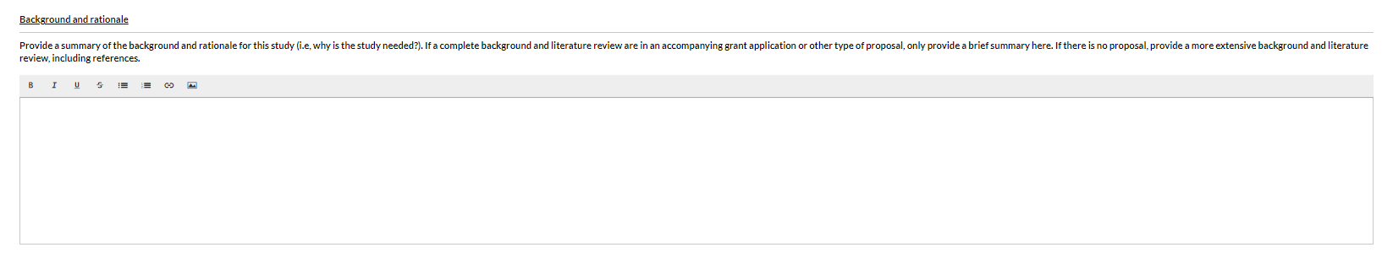
  - Study Procedures
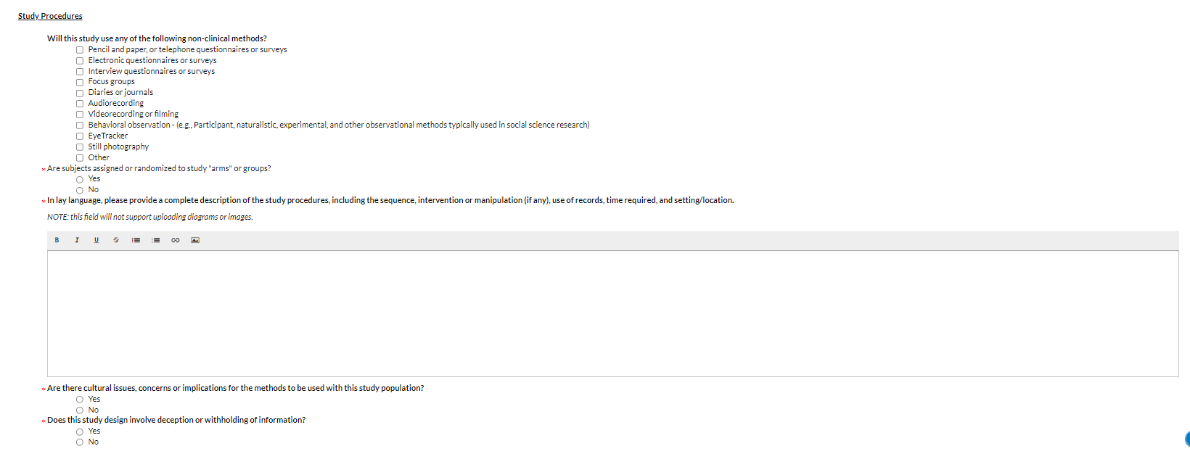
- Please indicate any non-clinical methods you will be using in your study. If you select certain methods (ie: Electronic questionnaires or surveys), you will be prompted to upload an attachment.
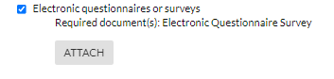
NOTE: Information about clinical methods will be obtained in a different section. Please refer to section 18 of this document for more information
- Please answer the additional questions in this section and provide additional information as requested.
If your study qualifies for an exemption, please skip to section 11.
- Study Design and Procedures (non-exempt)
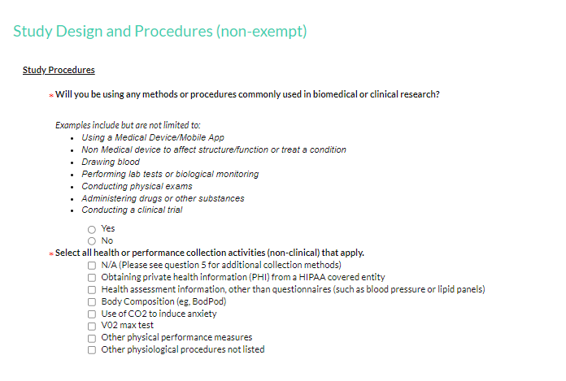
  - Please answer the 1st question as appropriate. If you answered “Yes”, the following section will appear:
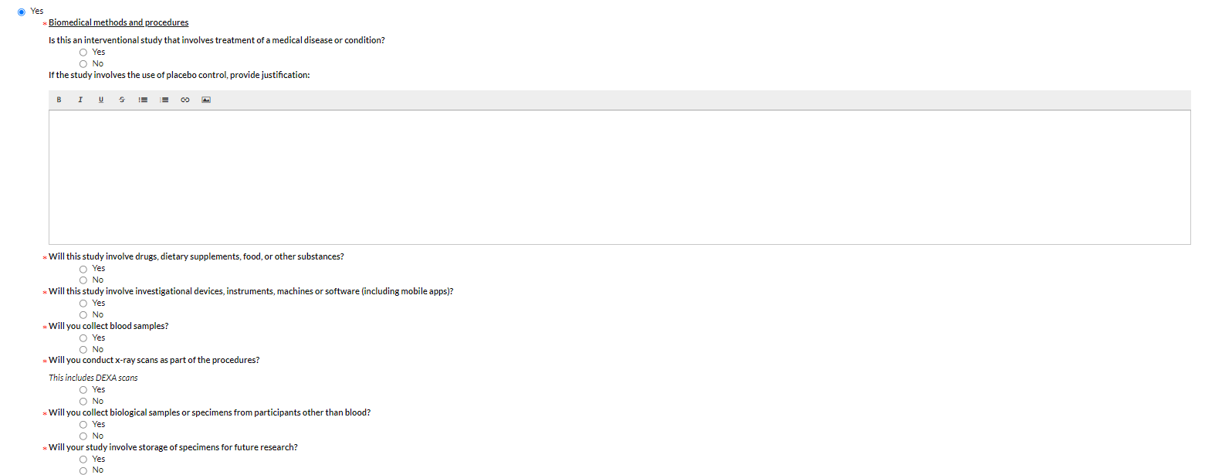
Select each procedures that applies and answer the additional questions that will appear for each procedure.
  - Please indicate any collection activities that apply for the last question

- Research Subject & Recruitment
  - Subjects
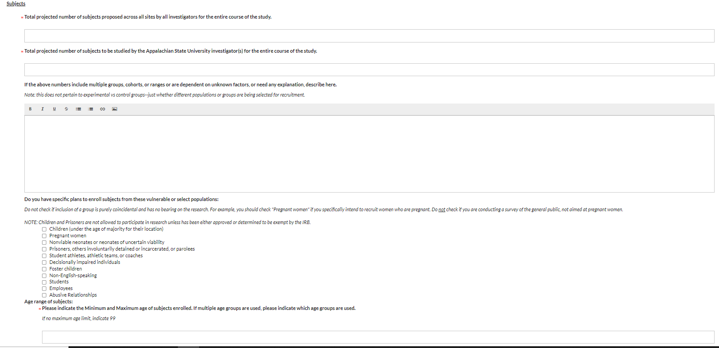
This section will obtain information about the research subjects you are looking to recruit. Please answer the questions as appropriate

  - Inclusion/Exclusion criteria
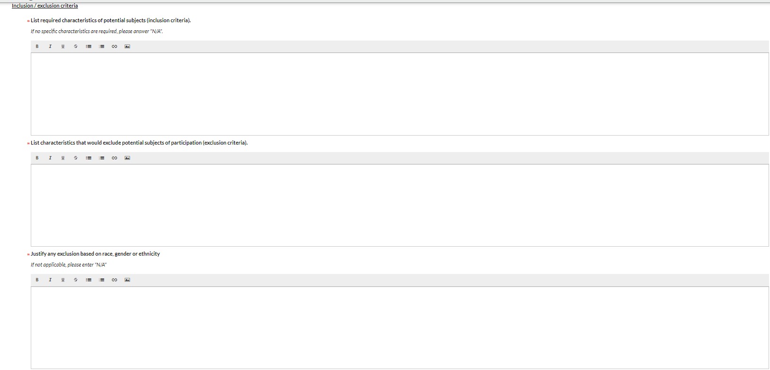
Please indicate any criteria that apply to selection of research subjects in this section

  - Methods of recruiting
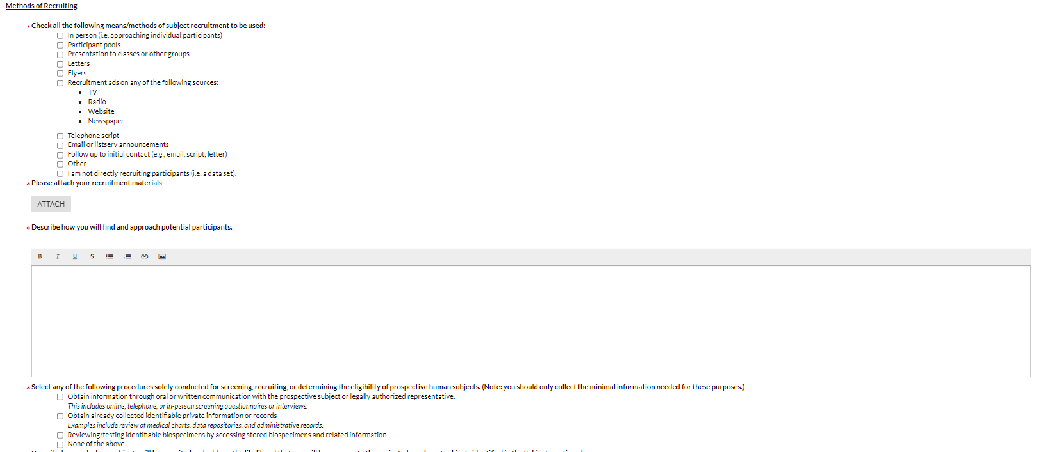
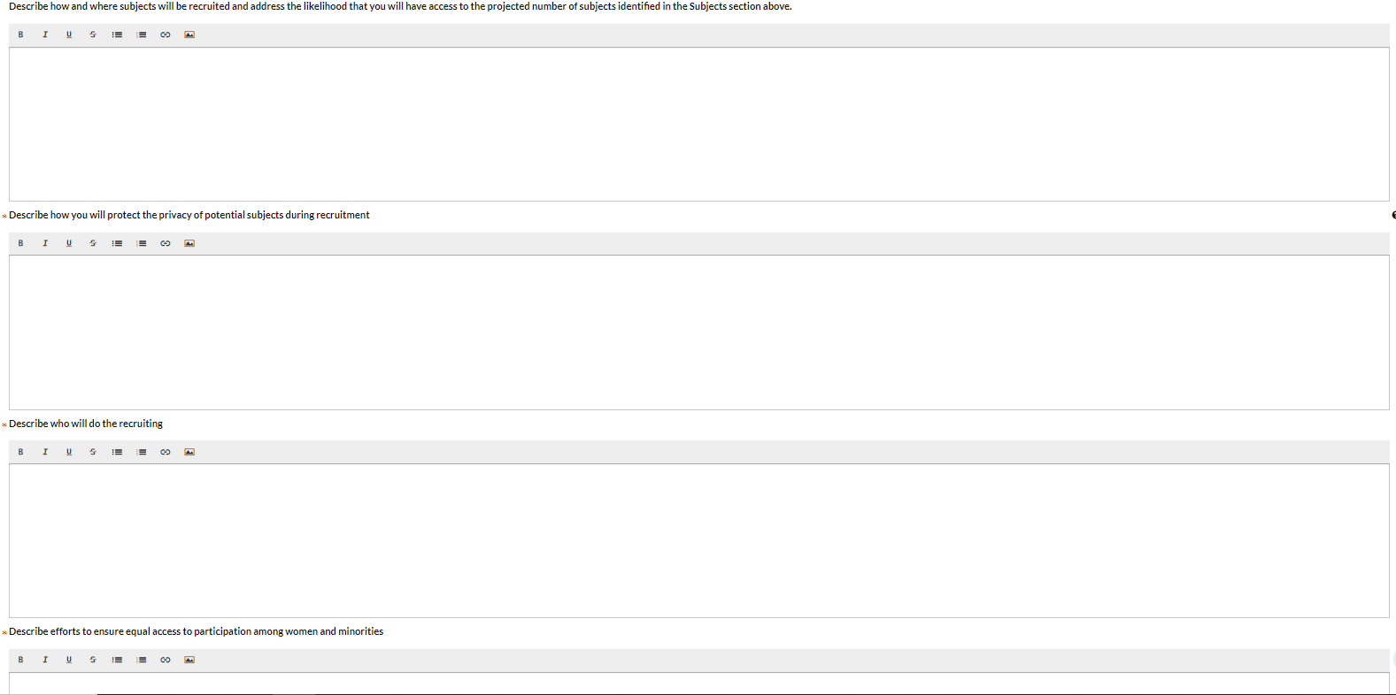
Please answer the question in this section to explain your recruiting methods
  - PHI
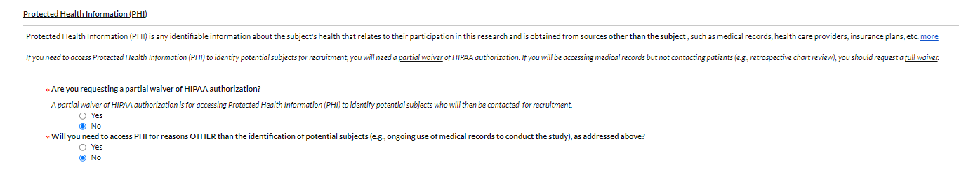
Please answer the questions as they pertain to Protected Health Information. If you are not working with PHI, answer “No” to both questions.
  - Subject Contact, Duration and Privacy
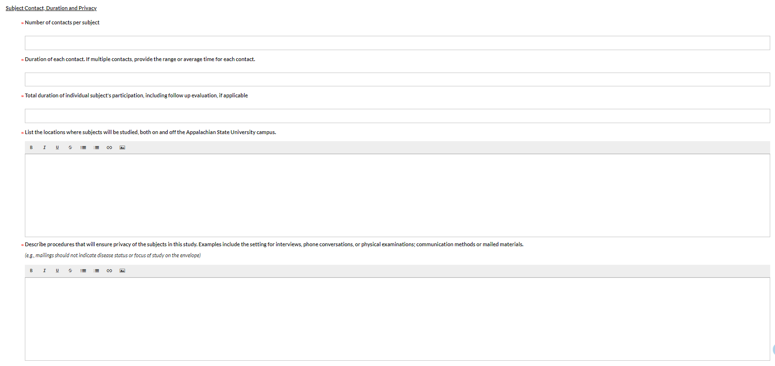
Incentives for participations
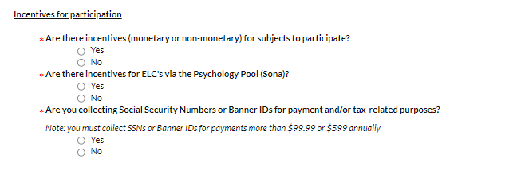
If you are offering incentives for participations, please indicate this in this section.

- Risks and Benefits
  - Risks and measures to minimize risks
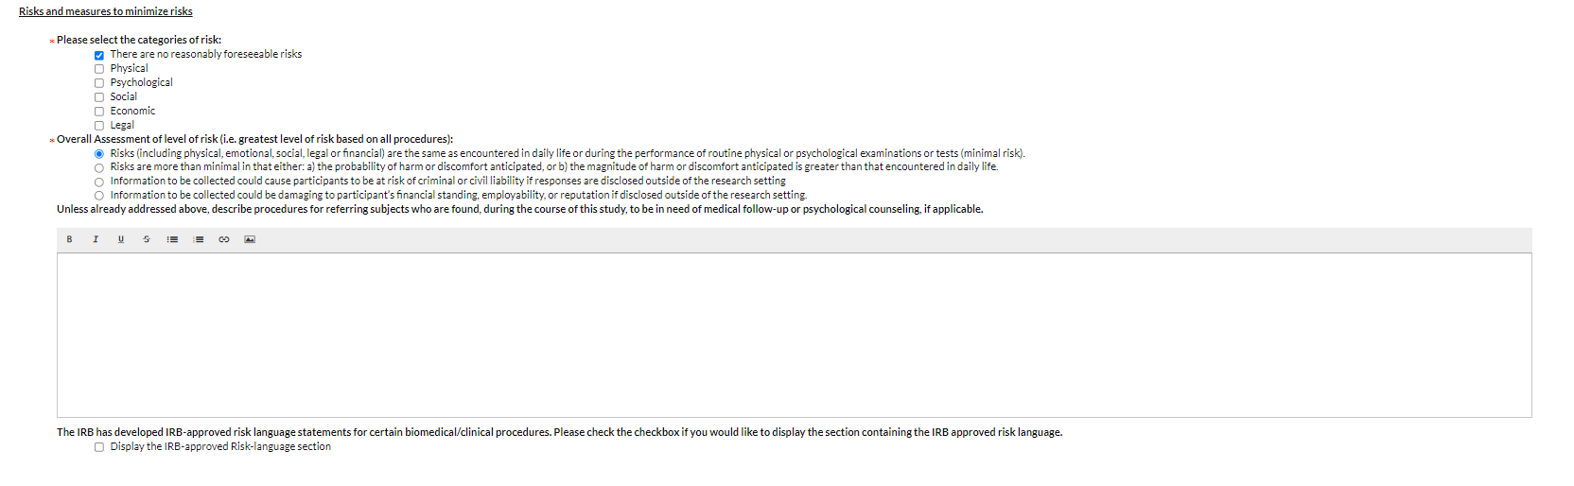
Indicate any risks in this section. If you have selected any risk more than minimal risk, please describe the procedures to minimize the risks. If you click on the Checkbox next to “Display the IRB-approved Risk-language section”, an additional section “Risks and Benefits will appear. Please refer to section 21 of this document for more information.
  - Benefits to subjects and/or society
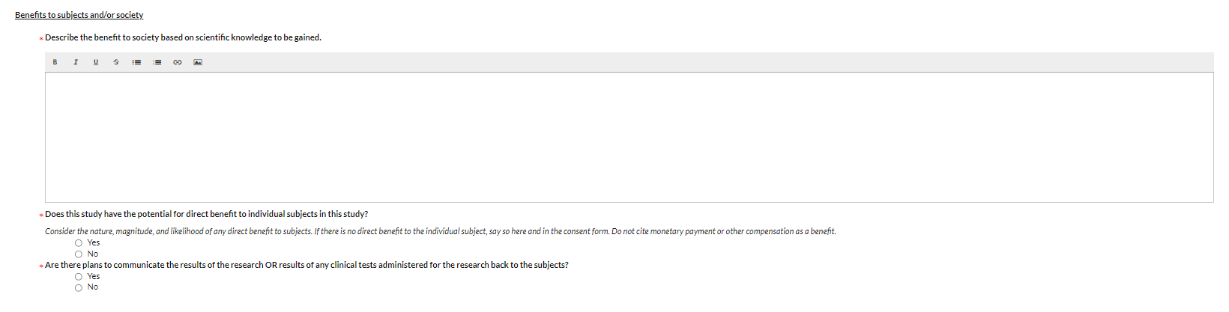
- IRB-approved risk language
This section will only appear if you checked the box to display the IRB-approved risk language. If you wish to display any risk language you want to use in your consent form or other documentation, click on the checkbox for to the appropriate risk language
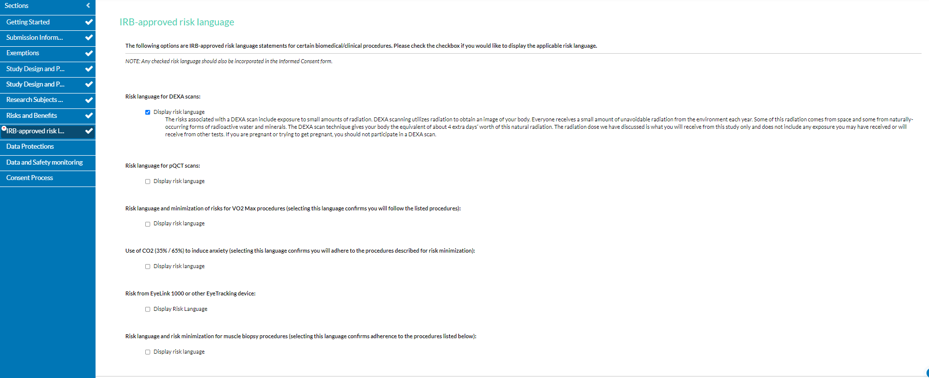
- Data Protections
  - Data Analysis
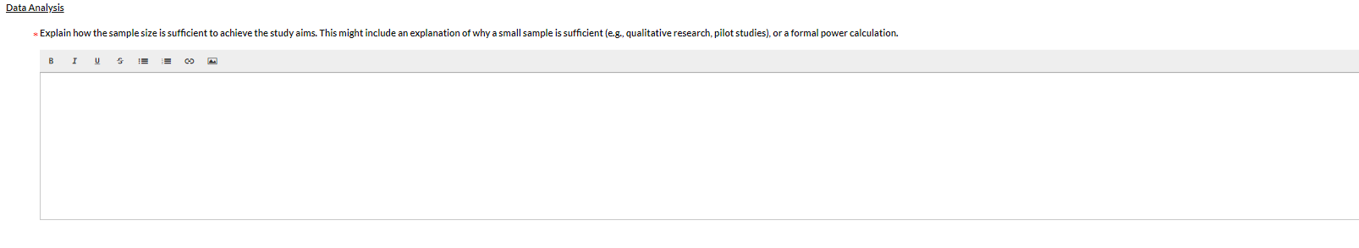
Complete this question to justify your sample size for the study.
  - Identifiers
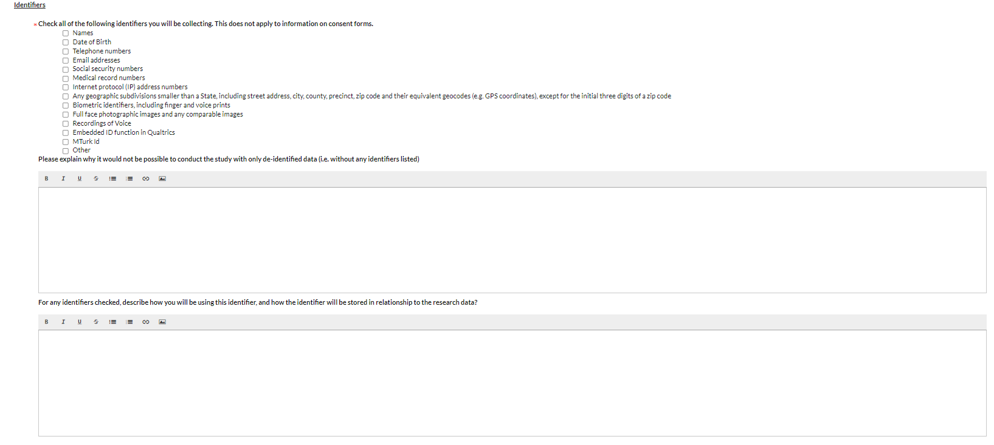
Please select any identifiers you will be collecting (if none, please leave blank) and answer the additional questions as needed.

  - Confidentiality of the data
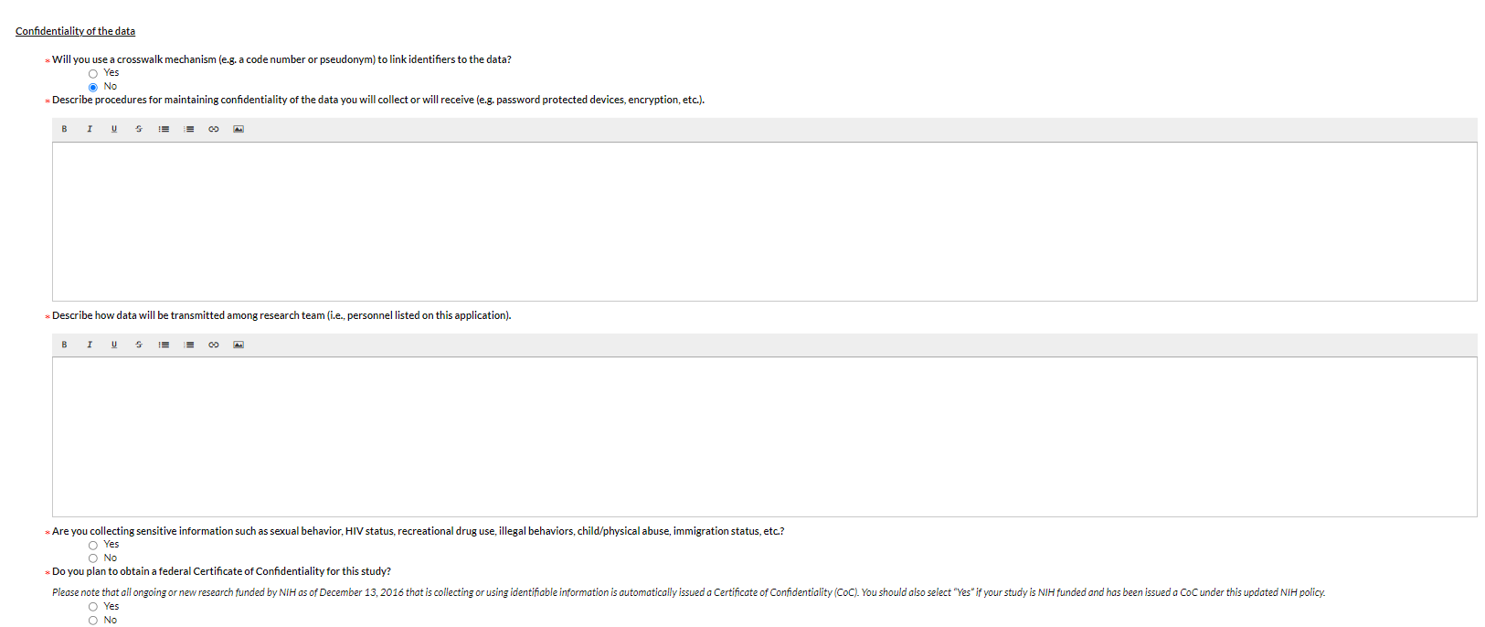
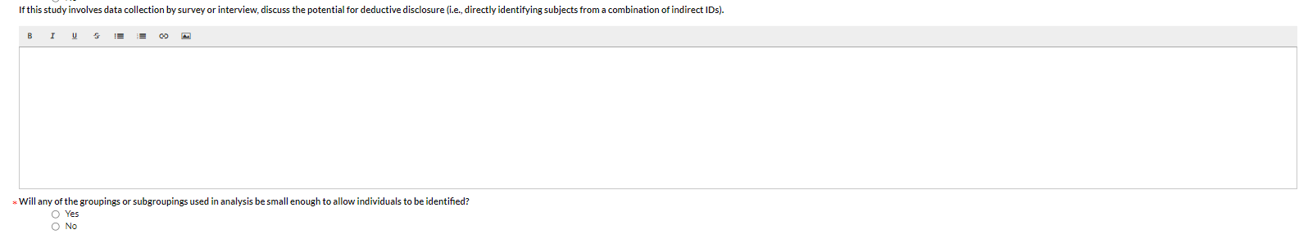
Please answer the questions in this section to indicate how the data you are collection will be protected.

  - Data sharing and transmission
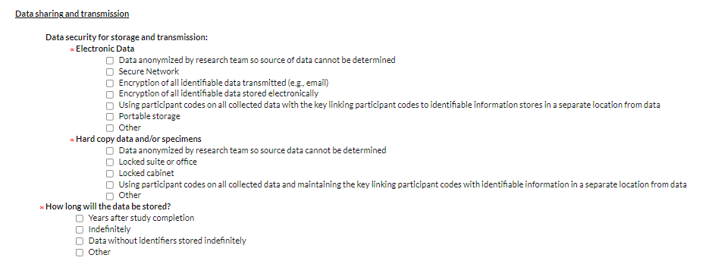
Please use this section to provide more details on how data will be store and transmitted.
  - Future use of data
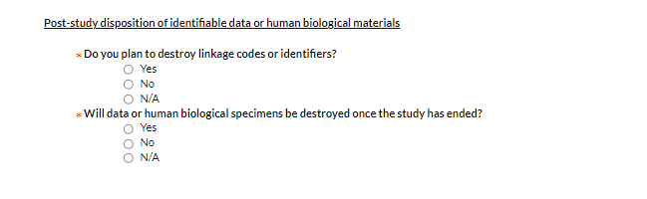
Please indicate how data will be disposed of, or if not, how it will be stored.
  - Data Sources
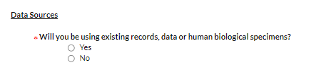
Please use this question to provide more information if you are using existing data.
If your study qualifies for an exemption, please skip to section 16.
- Data and Safety Monitoring
Please use this section to describe your plan to monitor the data to ensure the safety of participants in the study
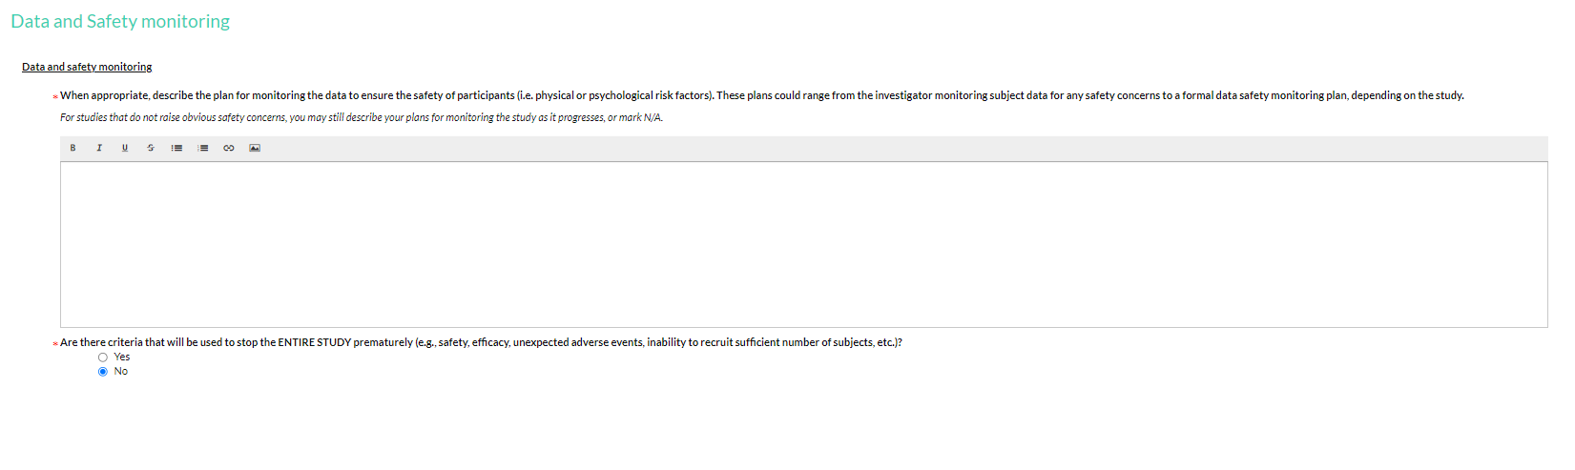
If your study does NOT qualify for an exemption, skip to section 17.

- Consent Process – Exempt
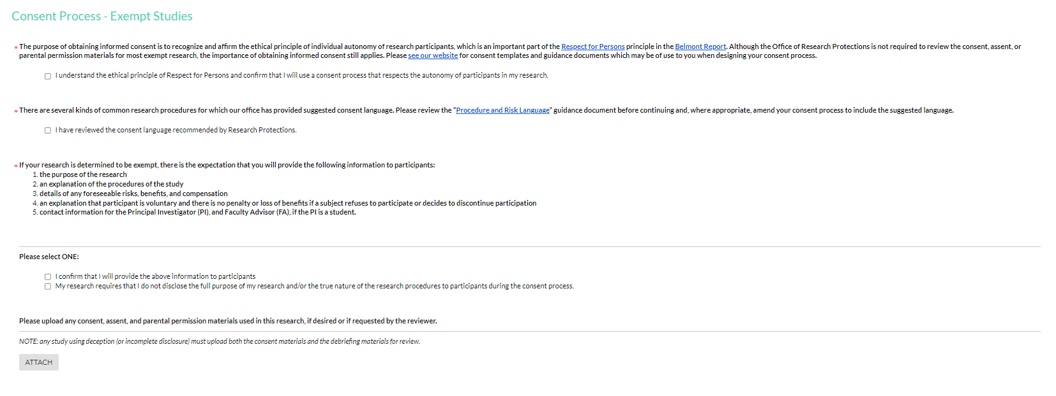
Review the statements in this section and indicate your acknowledgment by checking the boxes.
Select the appropriate statement that applies to your study
If desired, upload any consent, assent or other materials.

- Consent Process
  - Obtaining informed consent from subjects
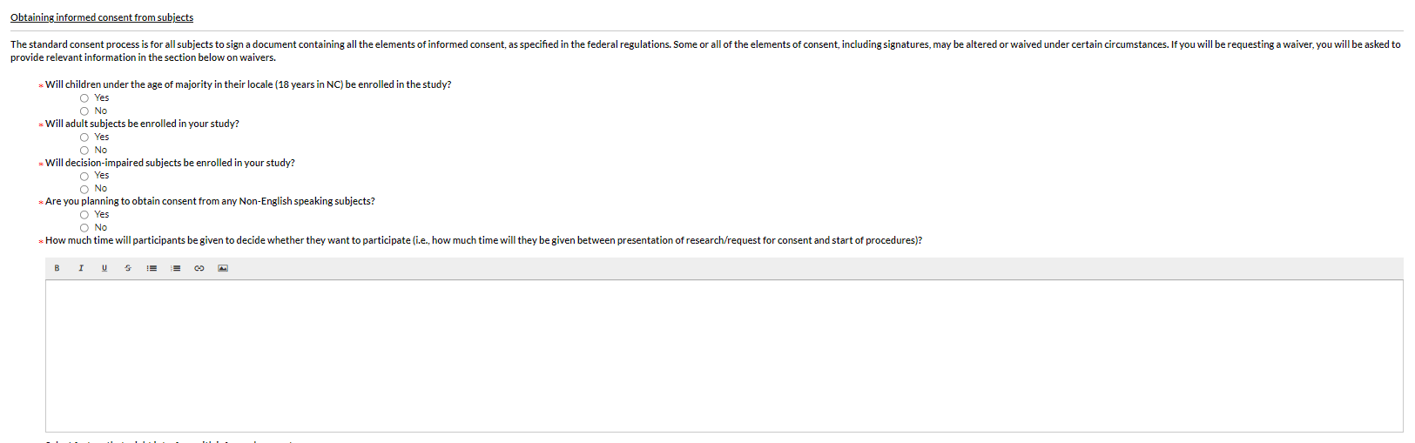
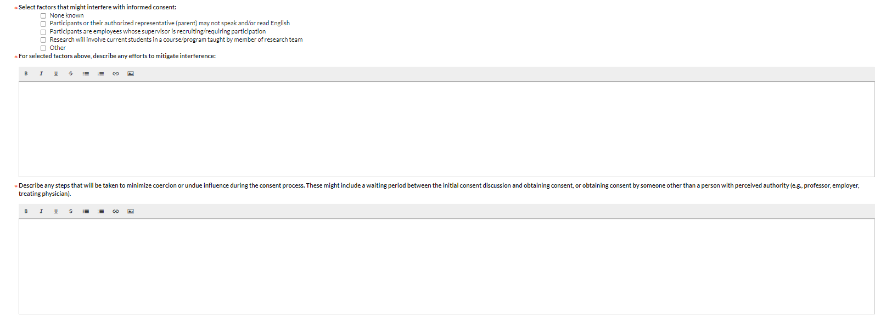
Answer the appropriate questions and additional prompts. In addition, please upload the requested documents as needed.

  - Waiver of written documentation of informed consent / parental permission
Please indicate here if you are applying for a (partial) waiver of documentation of consent. If yes, please provide the additional information as requested.
  - Full or partial waiver of consent / parental permission
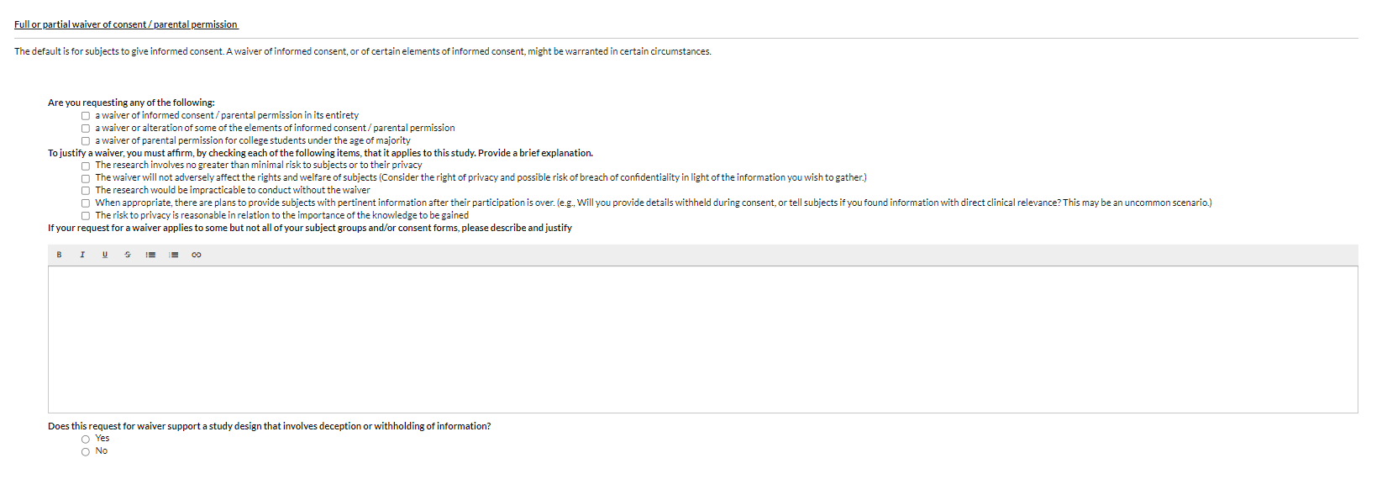
Please complete this section if you are asking for a full or partial waiver of consent and provide additional information.

- Routing – Complete Submission
After you complete each section in it’s entirety, the “Complete Submission” section will appear.
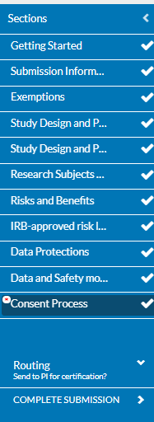
Click on Complete Submission to submit your form and click on Confirm in the pop-up screen.

- Certification
Once you have completed your draft, you will need to certify it in the screen below.
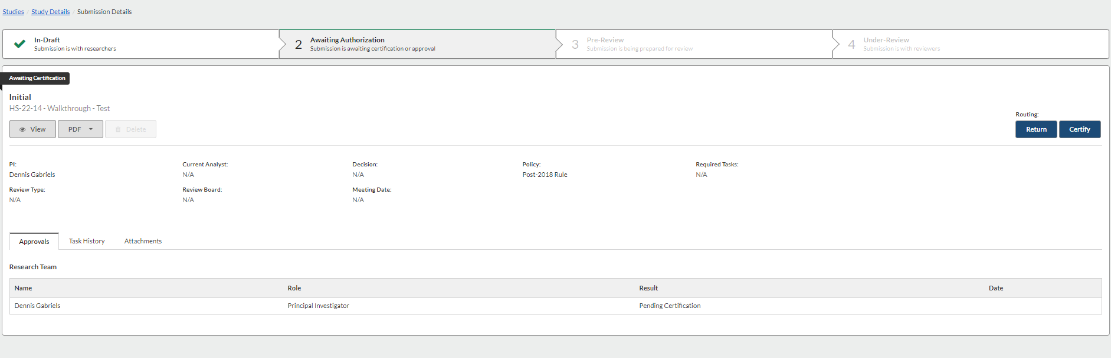
Click on the Certify button and “Confirm” in the pop-up screen. This will move your study to the Pre-Review status to be assigned to our IRB reviewer(s).

