OBTAINING YOUR PDF-APPLICATION AND APPLICATION ATTACHMENTS FROM IRBIS
- Log in to IRBIS (https://appstate.myresearchonline.org/irb)
- In the left hand menu, select “My Studies”
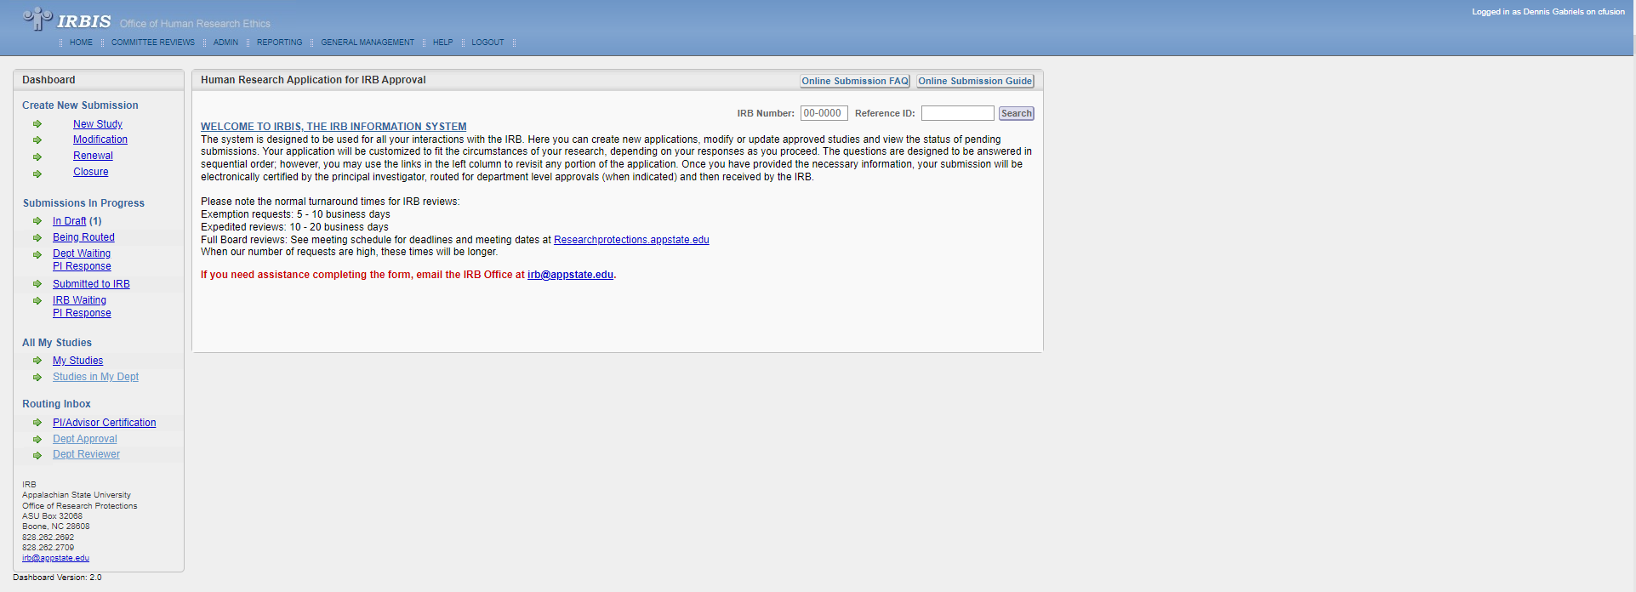
- Select the study from which you want to obtain the PDF-application and other study documents from the list on the following page
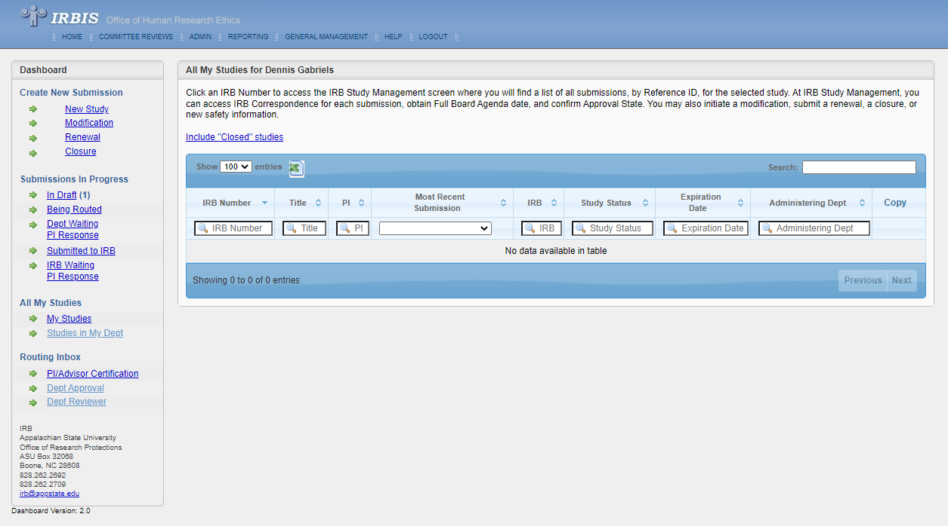
- Download the PDF-document for the application
  - Once you select the application, on the top of the screen, click on “PDF” to download the PDF-form (save in the following format: Study# - PI Name – Application)
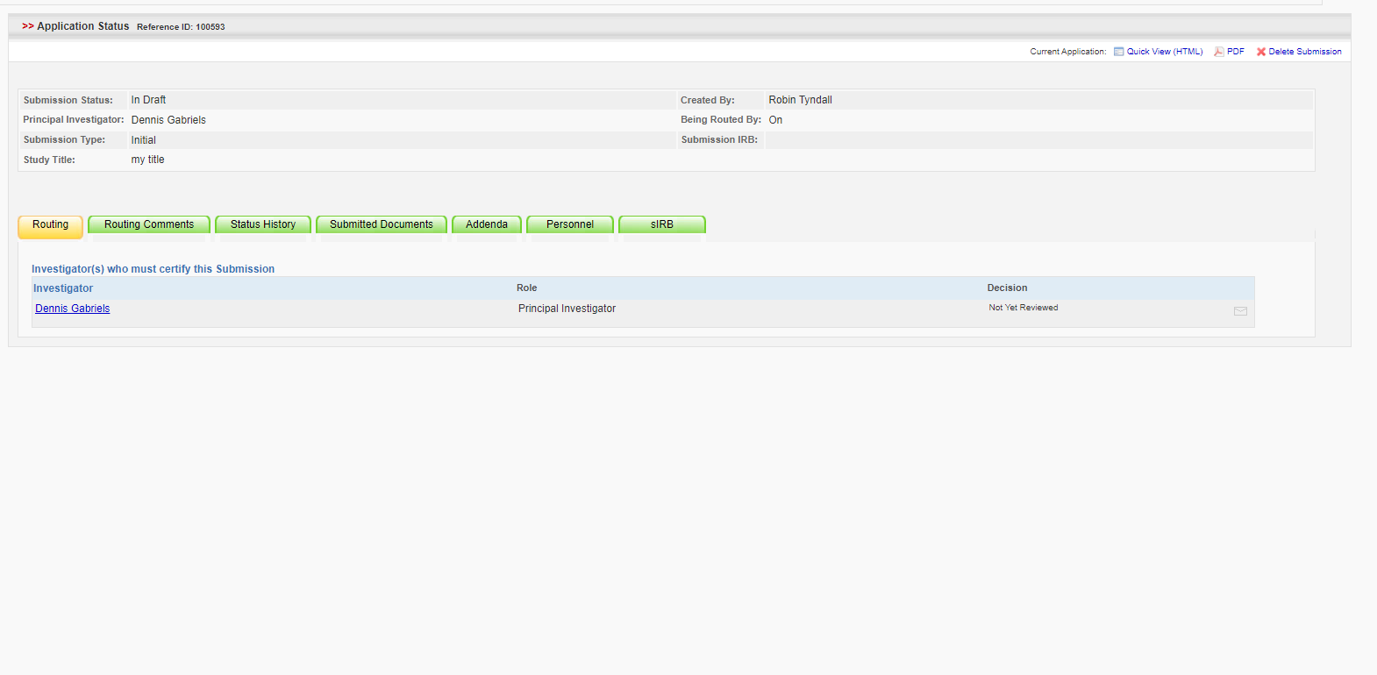
- Downloading documents related to the application
  - After selecting your application, click on “Attachments” in the left menu. Then click on the “Attachments” button in that menu.
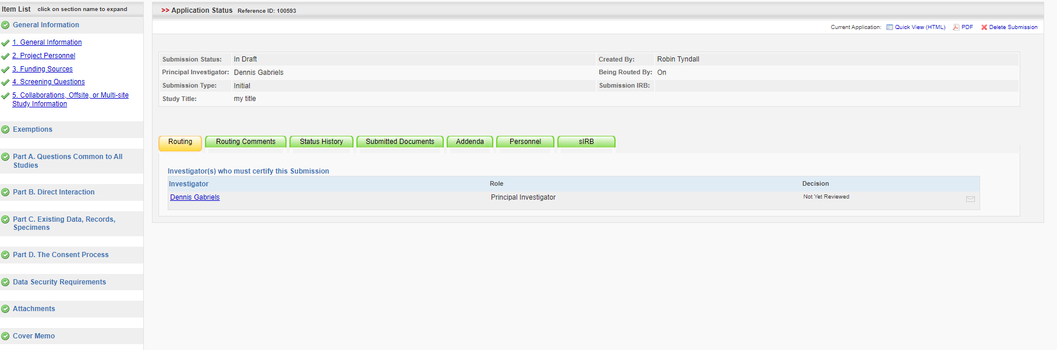
  - Scroll to the bottom of the next screen to section “3. REVISE/REPLACE PREVIOUSLY UPLOADED ATTACHMENTS”
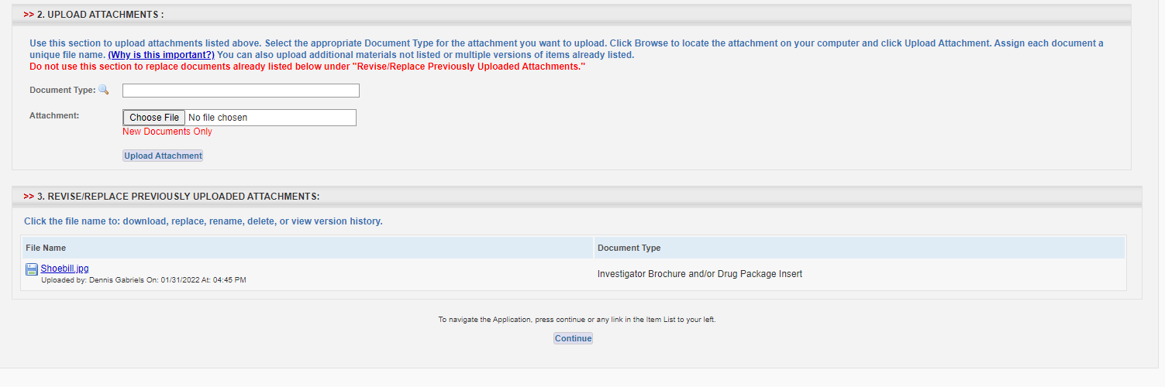
Click on the document you want to download and click on the “Download” button for that document. Save the document into your uStor or university Google drive with the following naming format: “Study # – PI Name – Name of Document”
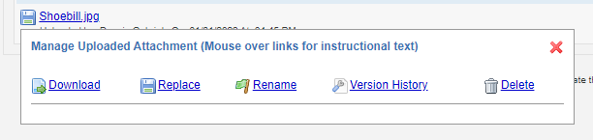
Repeat this process for each document attached to your application.

